**CHAPTER III**

**SYSTEM/SOFTWARE DEVELOPMENT METHODOLOGY**

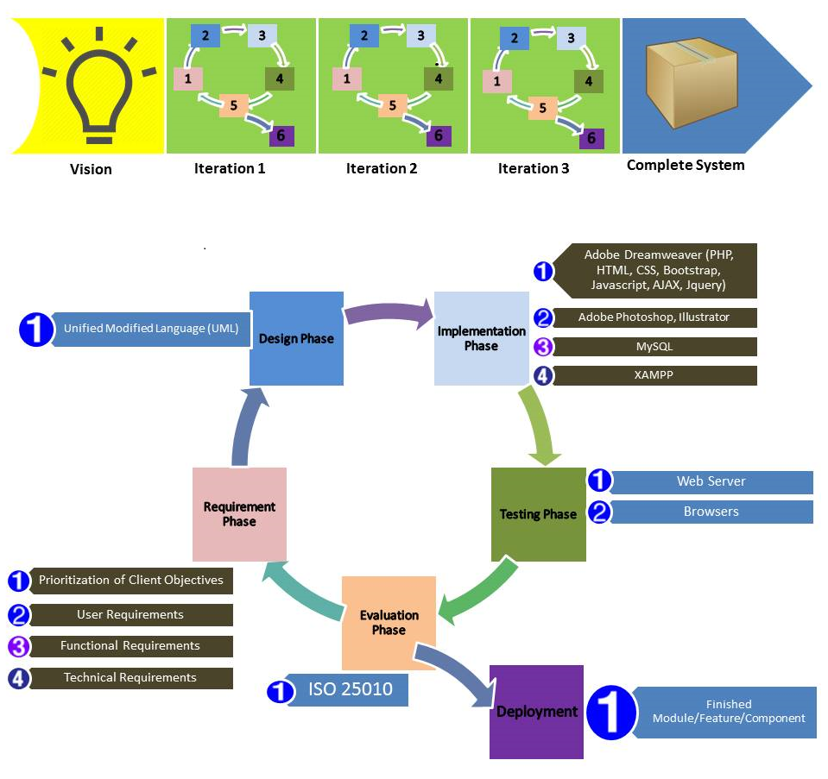

**Figure 1:** *System Development Paradigm using Agile Model*

The development of the ecommerce website is complex and need to be focus on different requirements area in order to successfully create a system out of the different components and features of the system. In this complex ecommerce website and incomplete client needs, Agile Methodology is intended to use. For developing of complex ecommerce system, breaking it to pieces will give a flexible management over the system. Every broken piece will be develop, evaluate by client and deploy the module then proceed to the next iteration. Client involvement in this methodology is one of the key to successful development of the software. If the client wants an early release of a specific features it can be possible on a matter of weeks or even days. Client will see that there is something happening and progress on the development of the software, somehow it can helps the client to have a peace of mind. Whenever client wants to add or change something in the development of software, it will be possible for the developers. Software development is much flexible when Agile method is used, so software developers too. Developers can always have positive response to the Client, but sometimes adding or changing something in the progress of the development can extend the time frame given upon software deployment.

The site seemed describes to indicate support about what is Agile Methodology (“Agile Methology,” 2008). Agile Methodology gives possibilities to estimate the management of a system in the entire development lifecycle. It helps teams respond to unpredictability through incremental, iterative work cadences. Agile methodology is an alternative to waterfall development. Agile methodology provides opportunities to assess the direction of a project throughout the development lifecycle. This can be achieved through regular cadences of work, known as iterations, at the end of the iteration a complete part of the system can be deploy. Every phase of the software development is continually revisited throughout the lifecycle. The “inspect-and-adapt” approach to development greatly reduces both development costs and time. Team can develop software at the same while gathering requirements, unlike in traditional model which can result to “analysis paralysis” that impedes a team from making progress.

**Vision**

In this very first phase of Agile methodology, Vision is the part that all of the involved in the development will collaborate including client and the development team. This way, client will tell to the developer what are inside the client’s mind such as what features and components should be included in the system which are usually written or spoken in a story format. Also in a collaboration meeting, developer shall suggest what are the features can be included in the development of the system. On both part of the involved party, this will be beneficial because of the idea that usually comes out when having a collaboration meeting. This various ideas regarding the development of the system will be organized in the next step.

**Requirement Specification**

In this phase, all of the unspecified objectives that discuss during the vision phase will be organize by the development team. To organize various objectives, development team need to anticipate what particular features is the best for those client objectives which usually logged in story format. Every objectives will be determine to assign each of them in a specified requirements such as user requirements, functional requirements and technical requirements of the ecommerce system. In User requirements, there are two types of users, the End User who browses the electronic store that has interest in purchasing and the Administrator who manage the electronic store. In Functional requirements, development team will specify the objectives and ideas of the system should do. Technical requirements specifies the behaviour of the system, all requirements that not visible in Functional requirements will be covered by Technical requirements.

**Design**

In this phase, development team will construct the architectural design of the system. In constructing the design, we will use Unified Modelling Language (UML 2.0) diagrams. UML 2.0 is a way of visualizing a system development using a collection of diagrams. In UML 2.0, four new diagrams are added and it has added the ability to define a hierarchy and split up the system into components. In using UML 2.0, it will be a much help for the development team because the different diagrams use will give visualization for the next phase of the development lifecycle.

**Implementation Phase**

In this phase, implementation of the previous phase will be tackle here. The previous phase serves as a blueprint of this phase, which gives the development team to visualize the different activity flow in the system. Development team will use different technology tools in this phase which is coding to develop different components of the system. Technology tools are PHP, HTML, CSS, BOOTSTRAP, JAVASCRIPT, JQUERY, AJAX which are handled by an IDE called Adobe Dreamweaver, for designing the front-end of the system, Adobe Photoshop and Illustrator will be use, for implementation of back-end, PHPmyAdmin and MySQL will handle the data, and lastly the XAMPP will use to testing the coding of the different components and features of the system.

**Testing**

In this phase, development team will upload the complete component of the system in web server to test it in the internet browser. Different internet browsers will use to make sure that the design of the front-end of the system is responsive. Different devices also use in this phase to test the responsiveness of the system on the internet.

**Evaluation**

In this phase, the development team will give evaluation form to different users including the client of the system. In this type of assessment, development team will assess the rating of the system according to different user’s evaluation. Evaluation is based on the ISO 25010 criteria, which are systems usability, functional suitability, performance efficiency, compatibility, reliability, security, maintainability and portability.

**Deployment**

After all of the previous phases are successful and zero bugs meet upon testing and when the client agrees and no suggestion in the finished component, this component will be deploy. When deployed, development team will proceed to next iteration and the previous complete component will be brought to the next iteration. Development of the system proceeds when every iterations are completed and it will be added to the next iteration until the complete proposed system is achieved.